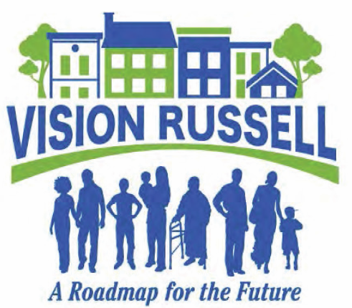
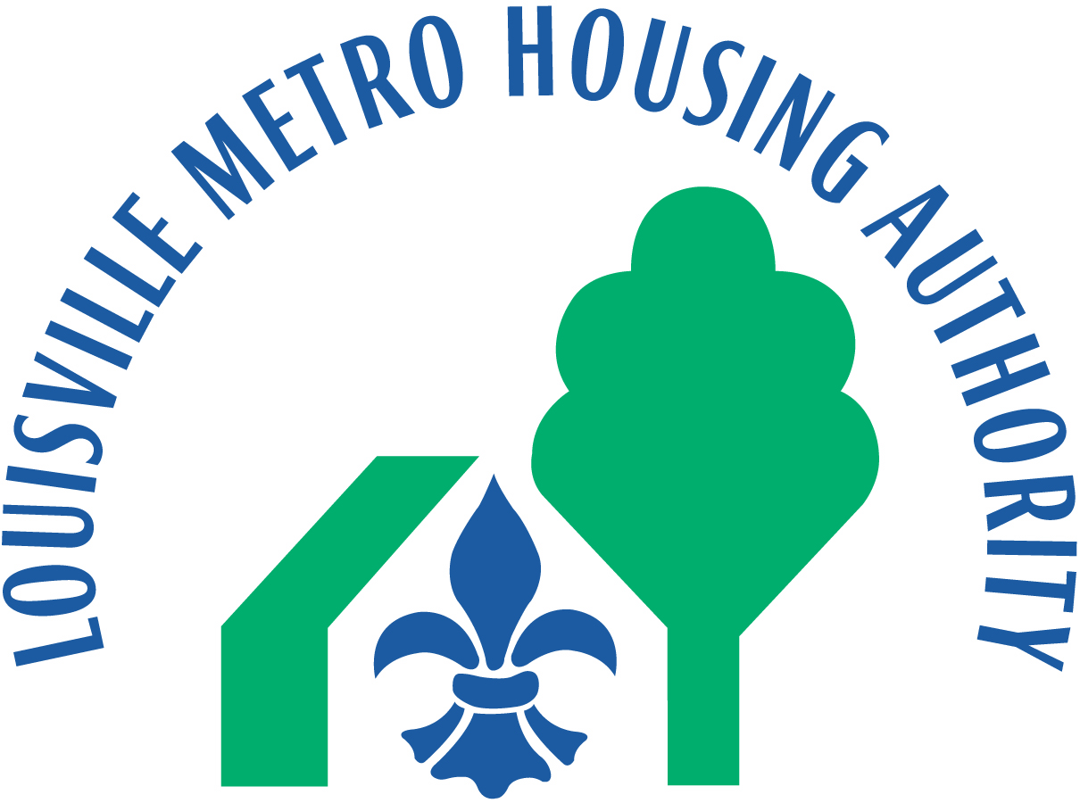

Beecher Terrace Choice Neighborhood

Beecher Terrace Background

- Beecher Terrace is located in the Russell Neighborhood, which is currently the focus of a FY2014 Choice Neighborhoods Initiative Planning grant and a FY2015/2016 Planning grant for Action Activities, and now the recipient of a FY 2016 Implementation grant.

- The severely distressed public housing development was built in 1939. The site, comprised of 31.40 acres on four super blocks, is bordered by Muhammad Ali Boulevard, Jefferson, 9th and 12th Streets, and includes a total of 758 one, two and three-bedroom apartments.

Choice Neighborhoods Initiative

- The Choice Neighborhoods Initiative (CNI) is a HUD-funded grant program that began in 2010, and replaces the HOPE VI Revitalization program. The 2-tiered grant program awards both Planning and Implementation grants. The program has three broad goals:
- To transform distressed public and assisted housing like Beecher Terrace, into energy efficient, mixed-income housing that is physically and financially viable over the long term;
- To support positive outcomes for families who live in the target development and surrounding neighborhood; and
- To transform high poverty and/or distressed communities into viable, mixed-income neighborhoods with access to well-functioning services, high quality schools and early learning programs and services, public assets and transportation and improved access to jobs.

Project Partners

- Nearly 600 team members and partner organizations are currently involved in the planning and implementation of Russell’s Transformation Plan, including Russell residents, businesses and other stakeholders, such as early childhood education providers, public and private schools, universities, health care centers, and faith-based organizations. Our CNI Implementation Team also includes the nationally renowned housing developer McCormack Baron Salazar, private lenders and investors, as well as staff from LMHA and more than 20 Louisville Metro Government departments.

General Highlights

- LMHA received a $425K Choice Neighborhood Initiative (CNI) Planning Grant in January 2015, and a $600K leverage contribution from Louisville Metro Government to develop a comprehensive Transformation Plan for Beecher Terrace and the Russell neighborhood.

- Russell’s Transformation Plan contains goals and strategies focused on four broad components:

  - People: plans to improve community and supportive services to be delivered to youth and their families.
  - Education: plans to improve children’s ability to succeed in school and to find occupations where they will thrive financially.
  - Housing: plans to transform distressed public and assisted housing and create high-quality, energy efficient, mixed-income housing that responds to the needs of the neighborhood.
  - Neighborhood: plans to create the conditions necessary for public and private reinvestment in Russell that will offer the kinds of amenities and assets, including safety, good schools, and commercial activities, that are important to families’ choices about their communities.

- Task force groups were formed to focus on each of these four Transformation Plan components.

- The community-endorsed, implementable, and financially feasible Transformation Plan will help revitalize the entire Russell Neighborhood, including Beecher Terrace.

- LMHA received a $1M CNI Planning grant for Action Activities on June 28, 2016, and a $375K contribution from the Louisville Metro Government. These funds will be used for physical improvements in the neighborhood that enhance and accelerate the implementation of Russell’s Transformation Plan. The Center for Neighborhoods led a polling process of Russell residents in September to determine the types of improvements they would like to see funded through this grant. The results showed strong interest in repurposing vacant lots, improving Sheppard Park, transforming TARC bus stops, and enhancing gateways. Proposals and ideas for these projects are currently being solicited. For more information on the Action grant visit www.visionrussell.org.

- LMHA submitted a CNI Implementation grant application to HUD on June 28, 2016, requesting $29.575M to help implement Russell’s Transformation Plan. These funds are leveraged with over $206M of additional public and private investment in the neighborhood.

- Louisville was awarded a $29.575M CNI Implementation grant on December 12th, 2016. Funds will be used for the construction, acquisition and/or rehabilitation of public, assisted and affordable housing on and off the Beecher Terrace footprint; demolition or disposition of properties; relocation assistance, including Section 8 vouchers; providing supportive services for residents, primarily focused on case management and service coordination for Beecher Terrace households; and other eligible expenses.

- The relocation of existing Beecher Terrace households will begin in the Fall of 2017, and be completed in phases. Demolition and remediation will begin in Spring of 2018, and construction will be completed by September 2023. The redevelopment of Beecher Terrace includes one-for-one replacement of all 758 existing units.

- A total of 640 housing units will be constructed on the Beecher footprint, including 620 mixed-income rental and 20 homeownership units. Construction would be completed in six phases.

- The new sustainable, walkable, and amenity rich Beecher Terrace community will feature commercial businesses on the first floor of select buildings along 9th and Muhammad Ali, and a renovated and expanded Art Deco style community center flanking an Olmsted-designed park.

The revitalized Beecher Terrace neighborhood will be designed and built per Enterprise Green Community and Energy Star standards. At least six residential units will be certified LEED v4 Homes, and LEED ND status will be sought for Beecher. To help fund these costs, LMHA applied for and was recently awarded a 2016 Affordable Green Neighborhoods grant valued at $44,500 which will provide technical assistance, monthly conference call support, and waivers of LEED ND registration and certification fees. Staff was also able to attend the Greenbuild Conference and Expo and Communities and Affordable Homes Summit in Los Angeles this past September as part of the grant award.

- Off-site replacement housing will be developed in mixed-income developments in high-quality neighborhoods throughout the city.

On-Site
640 total units including:

Rental
316 Affordable replacement
132 Affordable tax credit
172 Market-rate

Homeownership
6 Affordable
14 Market-rate

Off-Site
894 total units including:
8 Turn-key, mixed-income rental units in Russell
886 Rental units in mixed-income communities outside the neighborhood including:
438 Project-based Section 8 voucher (PBV) units
448 Market-rate

Section 3 and MBE/WBE/DBE Participation

- The Beecher Terrace Choice Neighborhood project will include an aggressive Section 3 program that is designed to help provide training, employment and contracting opportunites for economically disadvantaged persons.

- The Authority and its contractors have historically exceeded their goals for Minority, Female and Disabled Business Enterprise (MBE/FBE/DBE) participation for its projects, including all three of its HOPE VI Revitalization Developments (Park DuValle, Liberty Green and Sheppard Square).

- To achieve this consistently high level of performance, LMHA has a MBE/Section 3 Coordinator on staff.

Neighborhood and Building Design

- Urban Design Associates has crafted a master plan and will develop in conjunction with Sherman Carter Barnhart Architects, building designs and plans for a senior building, townhouses, multi-family apartments, mixed-income buildings and community areas that complement the architecture in surrounding neighborhoods.

Enterprise Green Community Standards

- All rental and homeownership units at the new Beecher Terrace development will be constructed according to Enterprise Green Community (EGC) standards. Housing designed and built to EGC standard has been shown to deliver significant health, economic and environmental benefits to families of all incomes. In addition, LMHA plans to apply for LEED-ND (LEED for Neighborhood Development) certification for the community, a system for rating and certifying green neighborhoods.

- Specific green features and activities at Beecher Terrace include:

- Recycling of demolished materials and construction wastes;

- Low-flow kitchen and bathroom faucets and toilets;

- Use of south facing windows and daylighting tubes;

- ENERGY STAR rated appliances, lighting, fans, and heating and air conditioning equipment;

- ENERGY STAR-compliant roofing and pavement which reflects heat in lieu of retaining heat;

- Use of vegetation to conserve energy, and landscaping that includes 50% native and adaptive plant material;

- Efficient water irrigation systems;

- Bio-filtration swales and an underground storm retention system;

- Electric vehicle charging stations;

- Low VOC (volatile organic compound) paints, primers and adhesives;

- Composite wood products with low or no levels of Formaldehyde;

- On-site organic waste composting and recycling stations in the parking lots on each block.

- In addition, all newly constructed Beecher Terrace units will be smoke-free.

- All Beecher Terrace households will receive a Resident Manual and orientation highlighting their home’s and community’s green features.

Community and Supportive Services for Residents

- An essential component of the Choice Neighborhood grant is the Community and Supportive Services (CSS) Plan. Urban Strategies out of St. Louis, Missouri will be the lead entity for the CSS Plan, which is designed to 1) prepare individuals for the transition from Beecher Terrace to their new communities during the revitalization process; 2) offer services that would create success in the workplace; and 3) move families towards a path of self-sufficiency.

- Programs and services include needs assessments and comprehensive case management services for all former Beecher Terrace residents; health care services that are accessible and affordable, including the HUD health initiative “With Every Heartbeat is Life”, which focuses on self-help management for chronic illness; job placement; financial skills training; a scholarship program for residents who are high school/GED graduates who wish to pursue higher education; recruitment for Early Childhood Education programs; transportation assistance; homeownership counseling and a Section 8 Homeownership program which offers subsidy towards a mortgage payment for eligible candidates.

- Beecher Terrace households will be kept abreast of these programs and services, along with progress on the Choice Neighborhood program, and education and employment opportunities, through a quarterly newsletter.

